Intrusion Detection System Using Passive Infrared Motion Sensor and Light Sensing Module

**Abhilash Mukesh, Meeti Baliga, Raunak Shah, Rohit Sudhakar Shetty.**

Student, Computer science and Engineering, M.S. R.I.T. Bengaluru, India

Abstract: In this paper we have designed and implement surveillance system by use of smart sensors like pyro electric infrared sensors (PIR) and Light Detecting Module (LDR) to detect an intruder in a house, ATM, Industries, Bank Locker room, storehouse or any other environment prone to thefts. The PIR sensors and the Light Detecting Module are placed on the ceiling, and the ultrasonic sensor module consisting of a transmitter and a receiver are placed vertically on the walls. We are then sending information like time, date, and the state of LDR when the intrusion has occurred to the authorized and related personnel via e-mail to avoid the storage cost. This system will also help to reduce the power consumption.

**I. INTRODUCTION**

Raspberry pi is a credit- card sized computer. It functions almost as a computer. There are various sensors used such as Passive Infrared Sensor, Light module. In these types of surveillance systems, the person who is stationary and is located in that particular area can only view what is happening in that place .Whereas here, even if the user is moving from one place to another ,he/she can keep track of what is happening in that particular place. Also another advantage is that it offers privacy on both sides since it is being viewed by only one person .The other major advantage is that it is a simple circuit .the operating system used here is Raspbian OS.Raspbian OS has to be installed so that the image can be transmitted to the smartphone.

**II. ARCHITECTURE**

As shown in Fig. 1our system which contains PIR sensor and light module. The PIR sensor is an electronic sensor that measures infrared (IR) light radiating from objects in its field of view. The light module detects the presence of a light source. Any intrusion detected by either the PIR sensor or light module sends a signal to the connected raspberry pi. This information is forwarded to the corresponding users email id via Internet.

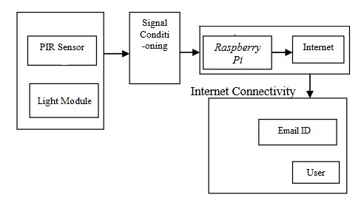

Fig 2.1 Architecture of the project

**III.SOFTWARE REQUIREMENTS**

Raspberry pi is a credit- card sized computer.The Raspberry Pi uses Raspbian operating system. Raspbian is an operating system based on Debian specifically design for Raspberry Pi hardware. Raspbian is optimized to produce faster performance on Raspberry Pi applications.

Hardware Implementation:

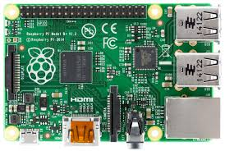

Fig 3.1 Raspberry Pi

We have used a raspberry pi 2 model B, which has the following hardware specifications:

* Broadcom BCM2836 Arm7 Quad Core Processor powered Single Board Computer running at 900MHz
* 1GB RAM
* 40pin extended GPIO
* 4 x USB 2 ports
* 4 pole Stereo output and Composite video port
* Full size HDMI
* DSI display port for connecting the Raspberry Pi touch screen display
* Micro SD port for loading your operating system and storing data
* Micro USB power sourceup to 1.2 AMP

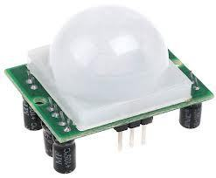

Fig 3.2 PIR Sensor Module

PIR sensor allow you to sense motion, usually to detect motion in or out of the sensor range.

* Output: Digital pulse high (3V) when triggered (motion detected) digital low when idle (no motion detected).
* Sensitivity range: up to 20 feet (6 meters) 110° x 70° detection range
* Power supply: 3V-9V input voltage, but 5V is ideal.

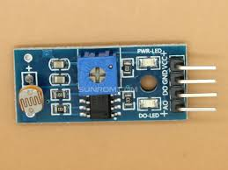

Fig 3.3 Light Detecting Module

The Grove - Light Sensor module incorporates a [Light Dependent Resistor (LDR)](http://en.wikipedia.org/wiki/Photoresistor). Typically, the resistance of the LDR or Photo resistor will decrease when the ambient light intensity increases. This means that the output signal from this module will be HIGH in bright light, and LOW in the dark.

* Voltage: 3-5V
* Supply Current: 0.5-3mA
* Light resistance: 20KΩ
* Dark resistance: 1MΩ
* Response time: 20-30 secs
* Peak Wavelength: 540 nm
* Ambient temperature: -30~70℃

**IV. FLOW DIAGRAMS**

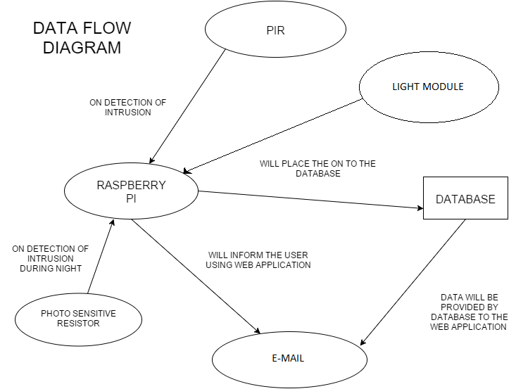

Fig 4.1 Data Flow

Fig 4.1 basically presents a basic application of Raspberry Pi in home automation control through internet (E-mail) where subject of the received e-mail is read by the developed algorithm fed into raspberry Pi and system responds to the corresponding instructions. The presented system is interactive, efficient and flexible according to the consumer needs. It immediately replies the status of work done by raspberry Pi to the consumer. The proposed system has been tested practically using LDR as it detects the intrusion also in the night and paces the data collected on to the cloud that is the google form and also sends the intrusion detected by an email to the authorizer.

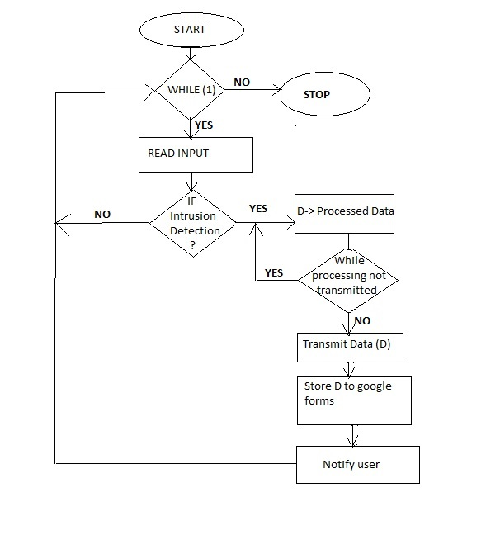

Fig 4.2 Flow chart

Fig. 4.2 describes the configuration of the proposed system. Raspberry Pi has been chosen as the processing unit for the system because of its user friendly features and economic benefits. Further, python coded algorithm has been fed into the raspberry Pi and is connected to the internet through Modulator Demodulator (MODEM) interface to access and send e-mails to the consumer. The Devices to be controlled have been interfaced with raspberry Pi using relay driver circuit due to different power ratings of devices and raspberry Pi. A display (optional) may also be connected to view the instantaneous status and processing of raspberry Pi.

**V. LITERATURE SURVEY.**

The security of one's belongings when a person leaves his/her house is always a concern with increasing number of incidents of theft, robbery etc. Many automated systems has been developed which informs the owner in a remote location about any intrusion or attempt to intrude in the house. Our project aim is that it sends us a notification when there is any intrusion in the way of the PIR sensor.

A similar project was conducted by SanjanaPrasad, P.Mahalakshmi, A.John Clement Sunder, R.Swathi Final Year M.E Communication Systems, BIT, Sathy, Associate Professor, BIT, Sathy.In the previous system, when the sensor detects an intrusion in its way then it is seen that the system would notify the user through a pop up message on the screen. We have made this better by implementing the notification system by sending an email about the intrusion. Through the email notification the user can backtrack about the details of any intrusion which would have happened previously. Even cameras were used to take photos and give some other details but it would consume a lot of power hence we have come up with another sensor known as the Light Detecting Resistor (LDR). With the help of this sensor we send out the information that whether the light was on/off at the time of intrusion.A camera is a brilliant way but the by using the LDR we have reduced a lot of power consumption. Even the photos taken by the camera would be shown as a pop up and hence there is no storage of the photos for further reference later on. Hence, this is a more effective way as reducing power consumption and have a stored information is more helpful.

These projects can provide several useful services such as support for the elderly and disabled people, access control, environmental monitoring, and home automation. With a rapid growth of necessity for a system to detect any intrusion in anyone’s property and with the increase in people using their email’s now a days this would be a very effective way of getting any intrusion details then a pop up box.

**VI. EXPERIMENTAL ANALYSIS**

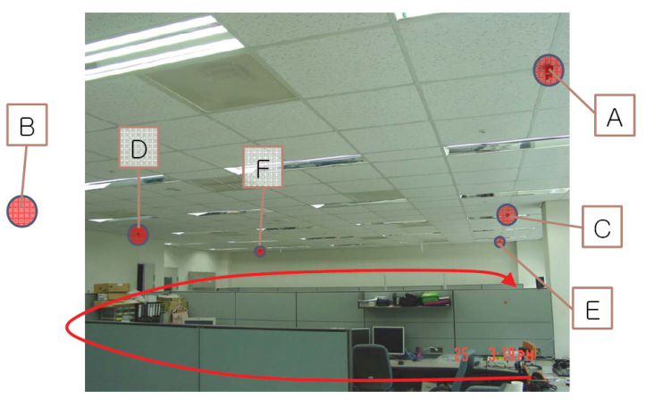

Fig 6.1

Figure 8 shows the indoor experimental setup and corresponding divided regions. As mentioned in the of the PIR sensor, if object enters from Z direction to the detection region, the detection distance will be shortened as in Figure 8. Therefore, we have installed the PIR sensors on the ceiling, so any object cannot approach the sensor from Z-direction We deployed 6 PIR sensors in 10.5m by 6.6m sized rooms the room is divided into 13 different regions as shown in Figure 7. This deployment and the divided regions have maximum error of 5.25m. In this experiment, a person over around in the room as shown in Figure 8 with a red arrow and the result is depicted in Figure 8.In indoor experiment, we have obtained very good performance of human localization. Since the object does not enter the PIR sensors from Z-direction so the assumption which is a basis for the region-based tracking algorithm is correct. Therefore, with an appropriate deployment and installation of PIR sensors, the region-based tracking algorithm using PIR sensors performs very well.

Why have we used PIR ?

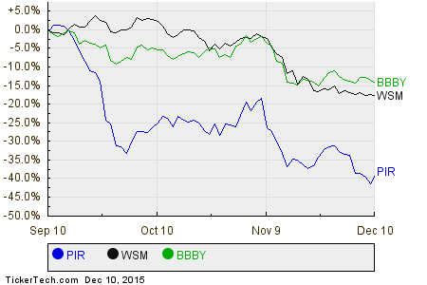

Fig 6.1

As shown if fig 6.1 the PIR sensor is typically mounted on a [printed circuit board](https://en.wikipedia.org/wiki/Printed_circuit_board) containing the necessary electronics required to interpret the signals from the sensor itself. The complete assembly is usually contained within a housing, mounted in a location where the sensor can cover area to be monitored. The housing will usually have a plastic "window" through which the infrared energy can enter. Despite often being only [translucent](https://en.wikipedia.org/wiki/Translucent) to visible light, infrared energy is able to reach the sensor through the window because the plastic used is [transparent](https://en.wikipedia.org/wiki/Transparent_materials) to infrared radiation. The plastic window reduces the chance of foreign objects (dust, insects, etc.) from obscuring the sensor's field of view, damaging the mechanism, and/or causing [false alarms](https://en.wikipedia.org/wiki/False_positive). The window may be used as a filter, to limit the wavelengths to 8-14 micrometers, which is closest to the infrared radiation emitted by humans. It consumes very less power when compared to other modules.

**VII. EXPERIMENTAL OUTPUTS.**

This Section shows all the experimental outputs

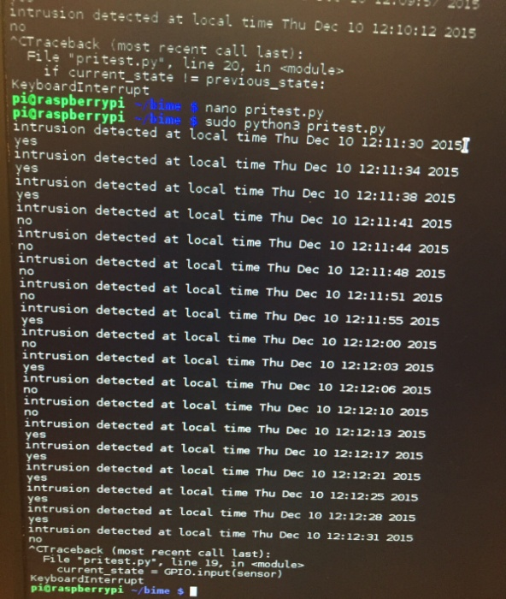

Fig 7.1 Output

The above Fig shows the output of the python code which depicts the intrusion detection and alos shows the data whether the light was on during detection.



Fig 7.2 Database

This is the screen shot of the cloud [Google form] which basically shows the information of detection of intrusion and the status of the LDR if it’s presently on or not



Fig 7.3 Email Notification

The above Fig 7.3 shows the email that is sent to the user whenever the detection has occurred.

**VIII. CONCLUSION**

This paper introduces a region-based human tracking algorithm with its actual implementation and experiments in real environment. The surveillance tracking system based on the PIR sensors proposed in this paper demonstrates a way to implement surveillance systems using currently available wireless sensor network technology. An evaluation of PIR sensor for surveillance systems and the effect of sensor deployment to the performance of algorithm are discussed. In addition, a mathematical abstraction of PIR sensor as a building block for the algorithm is provided and a region based human tracking algorithm is proposed. Finally, the actual implementation with currently available hardware and experiments and evaluations of the performance of the algorithm are discussed. More research is needed to track multiple humans in a single PIR sensor field in case that one or more intruders exist. Moreover, to extend the life time of the system, a method for low rate sampling with event time calculation for low power operation.

**ACKNOWLEDGMENT**

This project was done at M.S.Ramaiah institute of technology, Bengaluru, under the guidance of Respected K.G.Srinivasa Sir and the coordinator Respected Saumya B J Ma’am .Our sincere regards to them for supervising us in this project

**REFERENCES**

[1] P. Bahl and V. Padmanabhan, “RADAR: An In-Building RF-BasedUser Location and Tracking System,” in Proc. of the IEEEINFOCOM‘00, vol.2, pp. 755-784, March 2000.

[2] J. Hightower, G. Boriello and R. Want, “SpotON: An indoor 3D

[3] J. Liu, P. Cheung, L. Guibas, and F. Zhao, “A Dual-Space Approach.